**Punggol Secondary School**

**Sec 2 Subject Combination Mock Exercise**

**URL : https://punggol.schoolhub.sg**

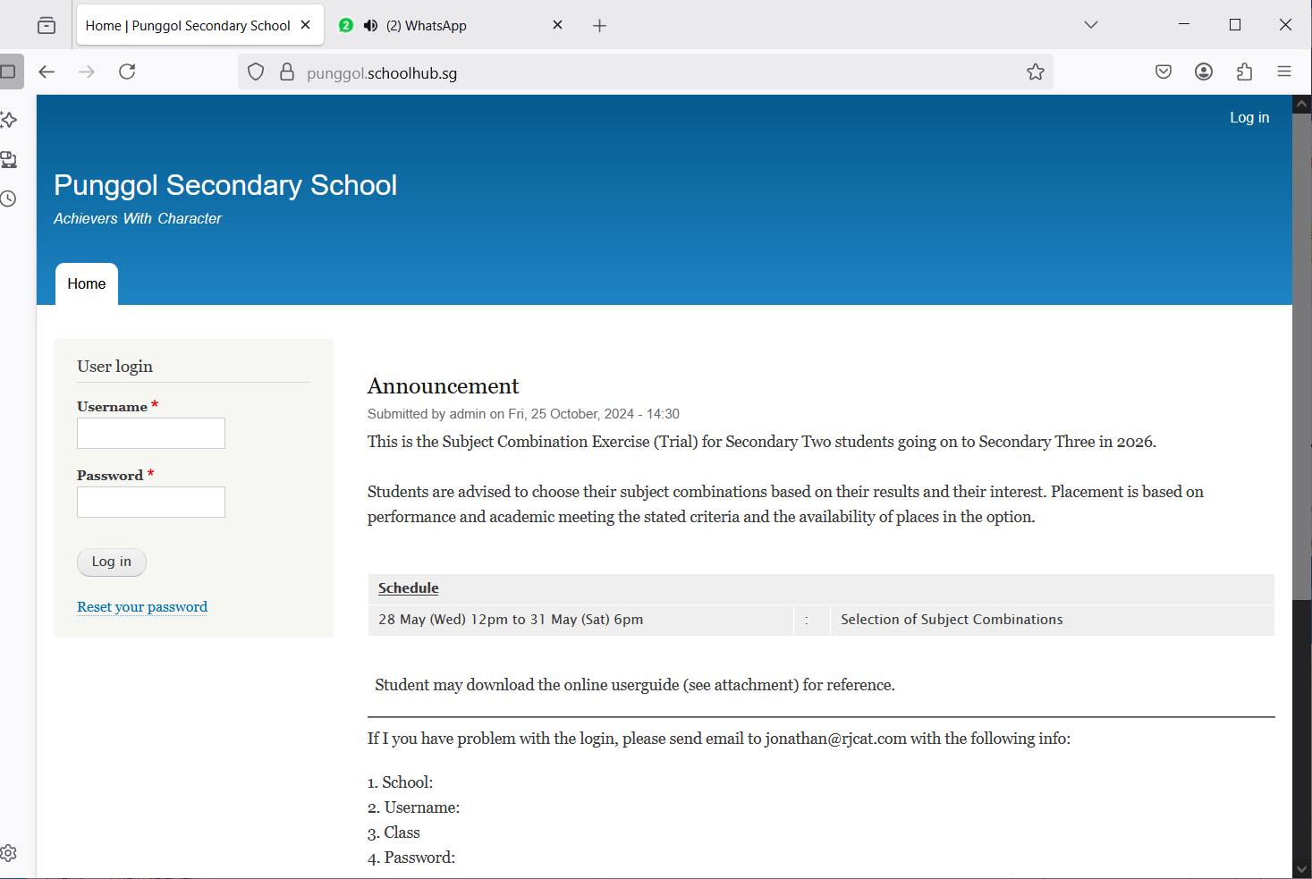

Steps

* Enter Username
* Enter Password
* Click Login

## Register Choices

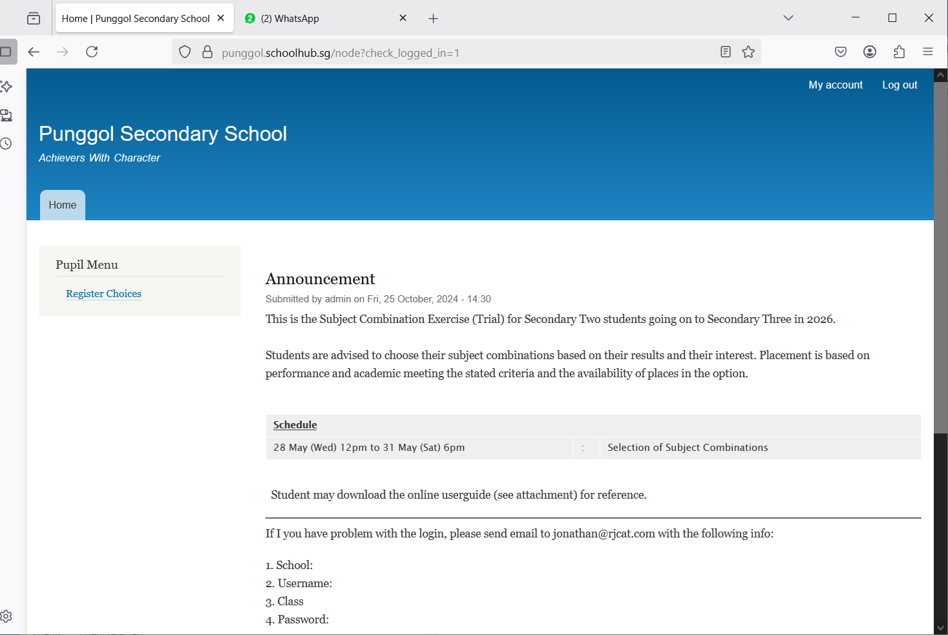

Steps

* Click Register Choices

The subjects are divided into different categories:

* EL - Compulsory
* MT - Compulsory
* MATH - Compulsory
* COMBINED HUMANITIES
* SCIENCE
* OTHERS
* C&T

You will need to rank all the subjects within each category. Please note that only subjects offered to you will be available for you to rank. For categories with only ONE Subject (Compulsory), it will be automatically rank 1.

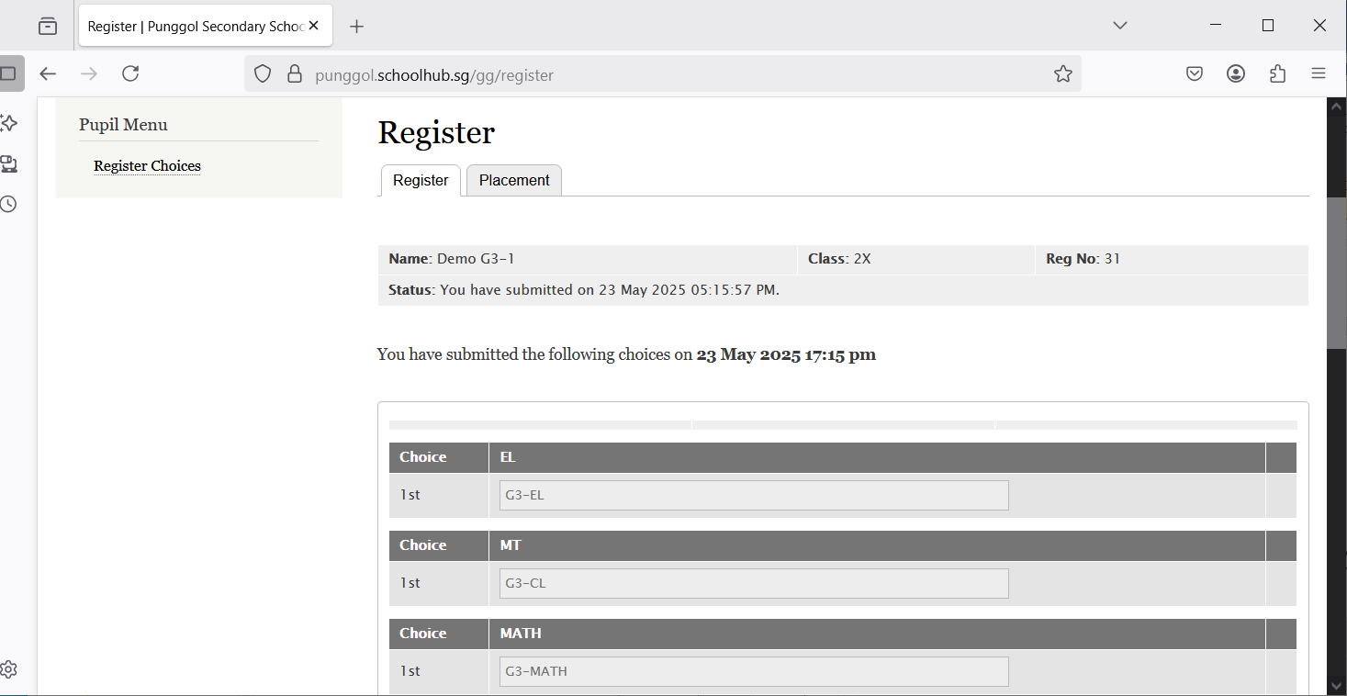

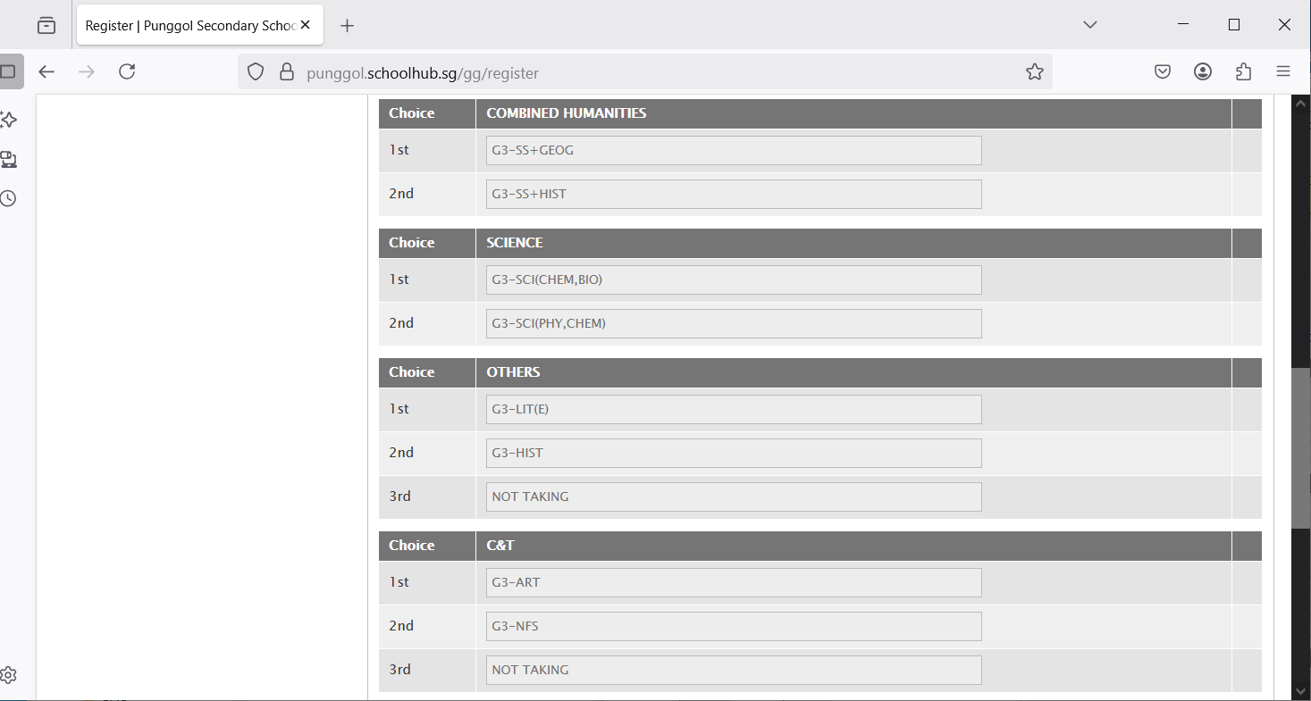

Hold and Drag to change your choices.  
for example:

Change G3-SS-Hist to 1st choice  
Change G3-SS+Geog to 2nd Choice

After changes:

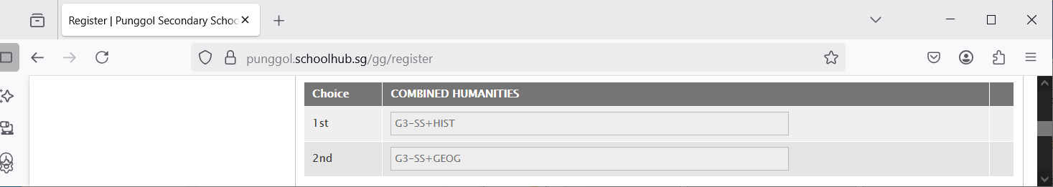

1st Choice = G3-SS+HIST

2nd Choice = G3-SS+GEOG

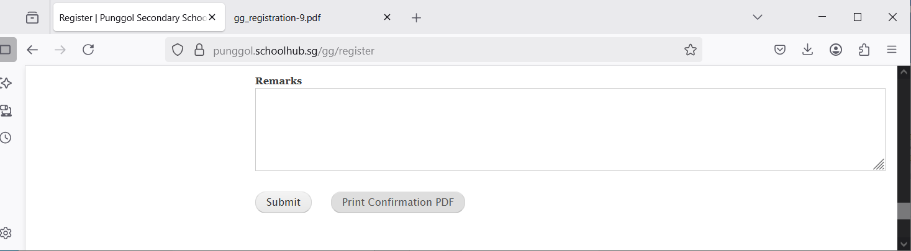

Enter any remark you wish to communicate with your teacher

Click Print Confirmation PDF to get a copy of the PDF for your reference.

Click Submit to save your choices. You may change them before the closing date.

## Sample Confirmation Slip

